

E-Barangay System

**Prepared by:**   
Arcellana, David

Cabral, Daren

Deluna, Jhonel

Lagman, Kamila

Sevilla, Christian

**ASIA PACIFIC COLLEGE**

**Submitted to:**

Edmundo Casino

**Project Client:**   
Abner, Arrieta Jr.

In partial fulfillment of the requirements for the

**SOFTWARE DEVELOPMENT**

Class of 1st term School Year 2016 -2017

September 7, 2016

Table of Contents

**I.** **Project Overview** 4

**II.** **Introduction** 4

Purpose 4

Scope 4

Objective 4

Target Audience 4

**III.** **Business Requirements** 4

Background 5

Business Opportunity 5

Business Objectives and Success Criteria 5

Customer or Market Needs 5

Business Risks 6

**IV.** **PROBLEM STATEMENT** 6

**V.** **SYSTEM REQUIREMENT ANALYSIS** 6

**VI.** **Vision of the Solution** 7

Vision Statement 7

Major Features 7

Assumptions and Dependencies 7

**VII.** **Scope and Limitations** 7

Scope of Initial Release 7

Scope of Subsequent Releases 8

Limitations and Exclusions 8

**VIII. RECOMMENDATION** 8

**IX. DIAGRAMS** 8

Context diagram 8

Data Flow Diagram 9

Entity Relationship Diagram 10

Class Diagram 10

Use Case Diagram 10

Sequence Diagram 14

Collaboration Diagram 17

Component Diagram 18

Composite Diagram 18

Deployment Diagram 19

Interaction Diagram 19

Package Diagram 22

Object Diagram 23

State-Machine Diagram 23

Timing Diagram 24

**X. SCREENSHOTS** 24

**XI. SOURCE CODE LISTING OF EACH MODULE** 24

**XII. BIBLIOGRAPHY** 24

# **Project Overview**

- The Barangay Project is a Web-based application that can store, receive, accept and process data of the user. These features fit perfectly to help citizens of the Philippines to easily experience the services being offered by the government and making use of the technology to their own advantage. With “helping Filipinos” in mind, developers were asked to create a system that helps the lowest form of the government which is the barangay. Every barangay in the Philippines provides services to their constituents. But with the Barangay Project, it brings “providing of services” to a whole new level. Government services that the barangay provides will be available online. From requesting an ID, clearance, business permit, submitting documents, to postings of current news, events and happenings in the barangay. And of course the system’s security will always be a top priority. That is why registration and approval are a critical part of the systems features and a requirement in order for users to actually use the system.

# **Introduction**

## Purpose

* + - The purpose of the Barangay System is to make of the efficiency because it will transform the old system into automated system. All the basic services of the barangay will be automated and all the data will be more secured and authentic.

## Scope

* + - The main process of the system is to collect information or data from the citizen who has been registered and it will have displayed the standard format of registration form. The bulletin feature is to inform the citizens what are the events, news, tips, and updates of the specific barangay. Also the system has the capability to give services in health, documents and education.

## Objective

* + - The objective of the system is to ensure efficiency and security. By now. The system does not need any estimates of revenue or cost savings, because the application will be handled by the barangay officials and it will have used by the masses. The transaction part will be on the barangay premises because if the requested document has a cost. The citizen will literally go to the barangay to get his requested file and pay for specific amount.

## Target Audience

* + - Our focused users will be the barangay citizens and officials. Helping them in managing and securing their own records.

# **Business Requirements**

* + - One of the business requirement of the Barangay System is to ensure the security of the database. Also it is efficient to use so that it can be accessible in any place as long as the user has an internet connection.

## Background

* + - One of the most problem in the barangay is using their old system that uses pen and paper. The problem with this, is the data that has been given to the barangay officials by the citizen is not really secured and sometimes not authentic. For example, the citizen of the barangay will be requesting for the barangay ID, the officials will question them about their name and how long they stayed in the barangay. Knowing that the citizen can faked the given data. In our system we strongly ensure that the data is legit and authentic. We will provide security features in the system and authentication, and make use of the data in future use.

## Business Opportunity

* + - The “Barangay System” should be implemented by the Barangays because the system has its user friendly environment also it is efficient and secured. The system will make sure the data that has been registered is authentic. The citizen of the barangay can register to the system in any age, and make use of the data in future and requesting for available services/documents. The system has its added feature that will give news, updates and tips for the specific barangay to get know more about what’s happening in their barangay. The system will automate the general services offered by the barangay like barangay ID, clearance, business permits and more, so that the citizen can request the specific services in their homes and other places as long as they have internet connection and they will be notified if the requested services is ready to receive. Also the system can have tracked down the incomplete process, missing file, and incorrect file send of the citizen in the requesting process, so that both citizen and official know what the error in the process and put correctly the right file or process*.*

## Business Objectives and Success Criteria

* + - The objective of the system is to ensure efficiency and security. By now. The system does not need any estimates of revenue or cost savings, because the application will be handled by the barangay officials and it will have used by the masses. The transaction part will be on the barangay premises because if the requested document has a cost. The citizen will literally go to the barangay to get his requested file and pay for specific amount.

## Customer or Market Needs

* + - Most of the barangay still uses the old system like pen and paper. The problem with this is that the data given by the citizen can be faked. The Barangay System will make sure that the data is genuine and secured in a way that the collected data that store in the database will not be released and only in the barangay premises.

#### Barangay System Display

- Registration Form (all fields are required)  
 - Selection of the available services  
 - Tracking of file   
 - Notification bar  
 - Bulletin includes News, Updates, Tips, Events and etc.

## Business Risks

* + - The risk that the user will be facing when the user uses the Barangay System will be, if possible.
    - The Notification of the request - One of the barangay official will be controlling all the requests of the citizen. The official must be responsible and active to notify the citizen about their requests, if not. The citizen who is request for the document, will not be notify and will not be informed about the errors and time receive for the requested document.
    - Loss of Internet Connection – If the user requesting for the document and the internet connection suddenly stops, we will not ensure if the system saves the previous process or it could be restart the process.

# **PROBLEM STATEMENT**

* The problem in most barangay is that they are using old system that uses pen and paper, the problem with this is the data that gathered is not secured much because there are some instances that the data might lose or destroyed by calamities or accidents.
* Also, some of the barangay citizens are not knowledgeable about the requirements in documents like barangay id, barangay clearance, Cedula, business permit and any other barangay documents, or they didn’t know about what’s happening in their community like events, news, happening or gatherings to attend.

# **SYSTEM REQUIREMENT ANALYSIS**

|  |  |  |  |  |
| --- | --- | --- | --- | --- |
| User Type | Role Description | Information Needs | Source of Data | Function on Data |
| Citizen | Request Documents  (e.g. barangay id, barangay clearance, Cedula, business permit, etc.) | Information in registration | Citizen information | Acquire documents after requesting |
| Barangay Official | Verifying request | Requested documents of citizens | - Citizens account | Officials get information of the citizen about their requested document |
| Super user | Root | Data of all users | Barangay Official and Citizen | Control the system |

# **Vision of the Solution**

* + - We have this vision that the Barangay System will be developed correctly. We will make sure we chose the right decision and organized everything on time as long as possible.

## Vision Statement

* + - The Barangay System provides the best solution and services for the community in the barangay. The system makes sure the best simple design for the friendly interaction for the user and secure the data’s and information.

S

### Major Features

These are the major features of the Barangay System

Document Requesting - The documents like Barangay ID, Barangay Clearance, Cedula and any other common documents requested in the barangay will be automated in the Barangay System. It requires internet connection, so that the process will be real time.

Requested File Notification – This will notify the user in the system, if the requested file is ready to claim to their specific barangay.

Bulletin – This feature will display will be display about NEWS, updates, events, tips and etc. Especially about health, education and information.

## Assumptions and Dependencies

Assumption and Dependencies – The assumption will be if the system successfully received the request and process it, possibly the system will be upgraded that will add more services and other features needed.

# **Scope and Limitations**

* + - In the project our client said that the Barangay System would be general therefore the major activities of the system would focus only in information, education, and health. Our client requires also a mobile and a web based application. The activities of the system is getting data from the citizen to give them privilege in every service that the barangay offers.

## Scope of Initial Release

* + - The main process of the system is to collect information or data from the citizen who has been registered and it will have displayed the standard format of registration form. The bulletin feature is to inform the citizens what are the events, news, tips, and updates of the specific barangay. Also the system has the capability to give services in health, documents and education.

## Scope of Subsequent Releases

* + - For the development of the system. We will be focusing on the main process/feature of the system, like the registration process, requesting, notifications and much more. It will take much time to test and to code every process. The only major feature will be deferred to later release is the minor features of the barangay system like the bulletin feature, because it will just display news, events, tips, and updates of the barangay.

## Limitations and Exclusions

* + - The features that will include in the future needs of the specific barangay is the service in other category, because the main features of our system focuses only in information, education, and health.

# **VIII. RECOMMENDATION -** We recommend to use our E-Barangay system because there will be better proposal in the future like:

* Users can pay online through external payment centers / gateway
* System can able to work even offline (provincial)
* All government documents can able to request in the system
* TV white space accessible
* Alert SMS for emergencies

# 

# **IX. DIAGRAMS**

## Context diagram

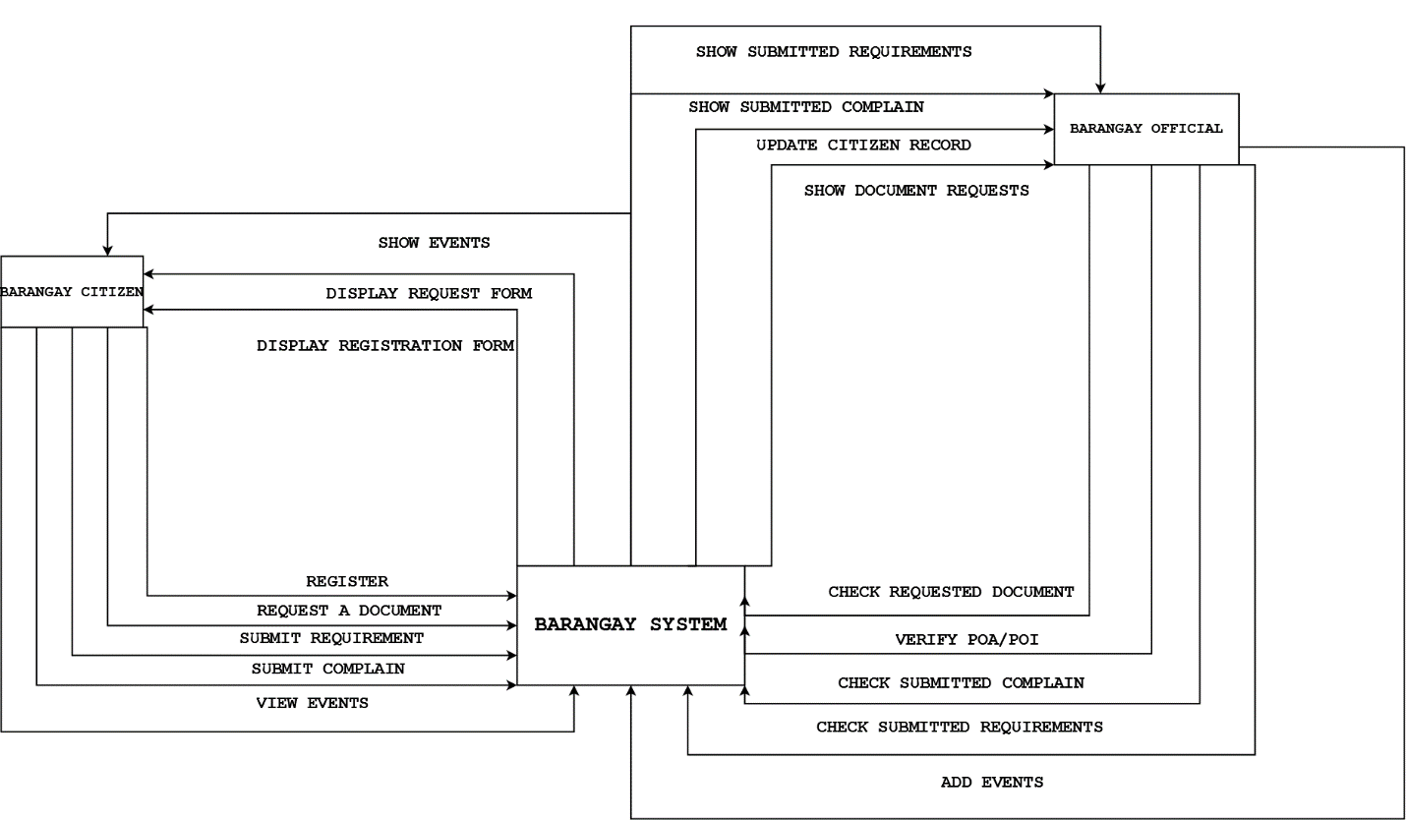

## Data Flow Diagram

#### Level 0

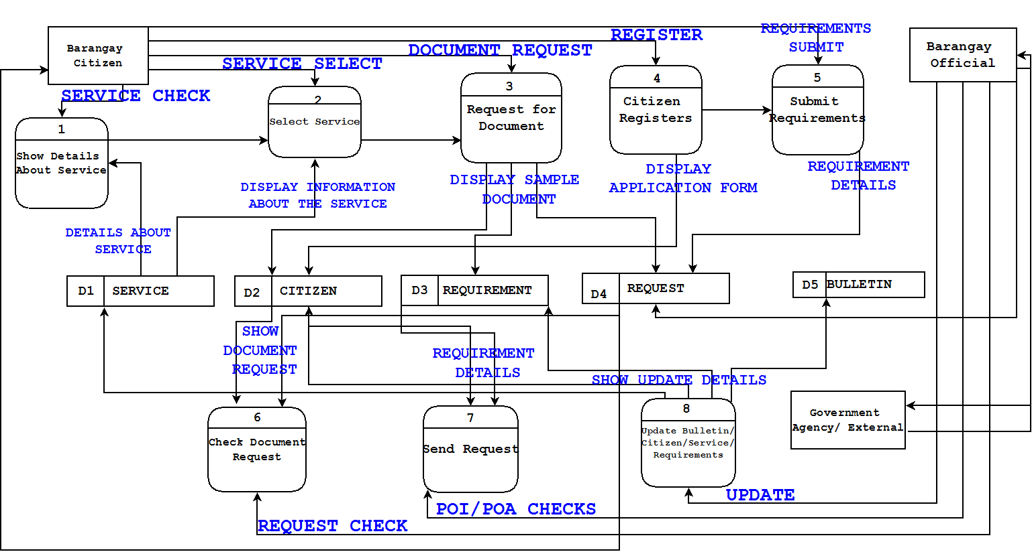

#### Level 1

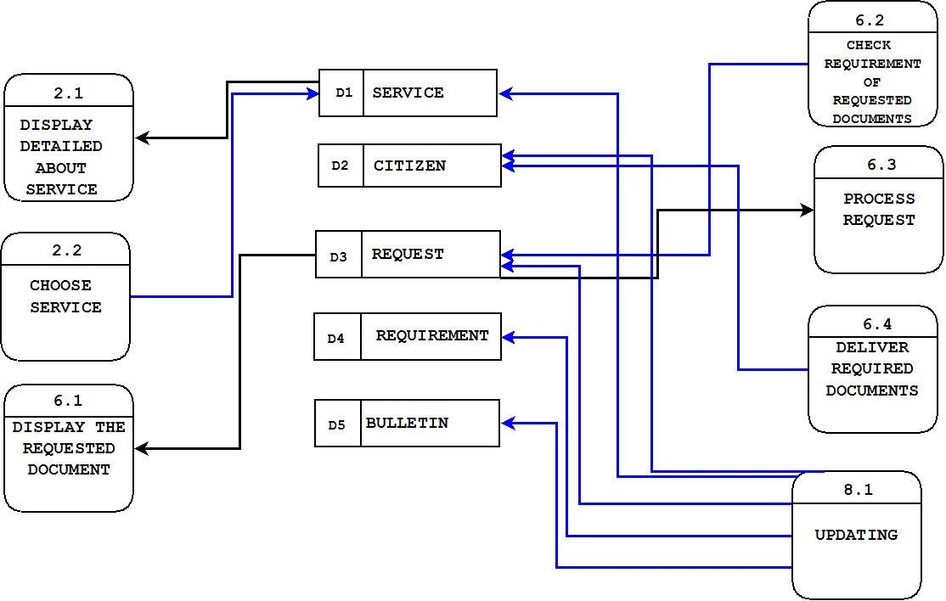

## Entity Relationship Diagram

## Class Diagram

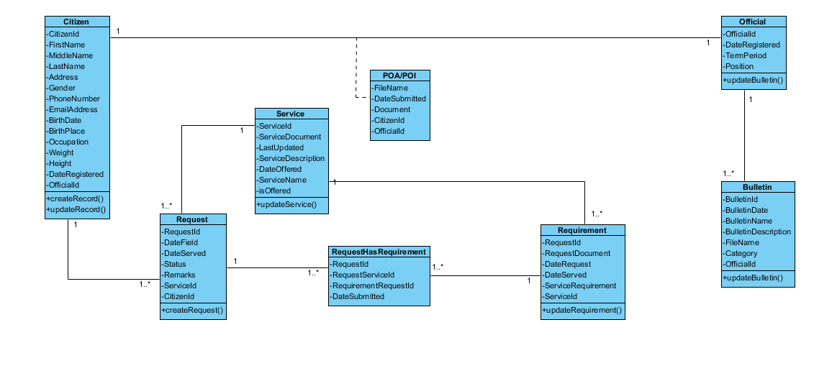

## Use Case Diagram

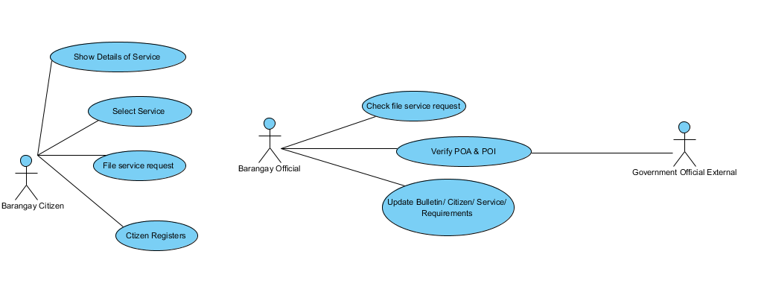

Activity Diagram   
(Select Service)

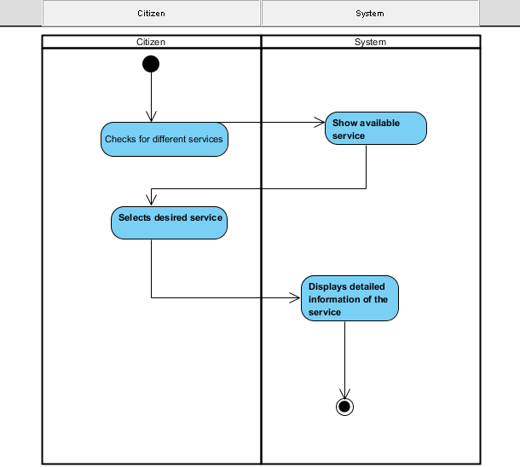

(File Service Request)

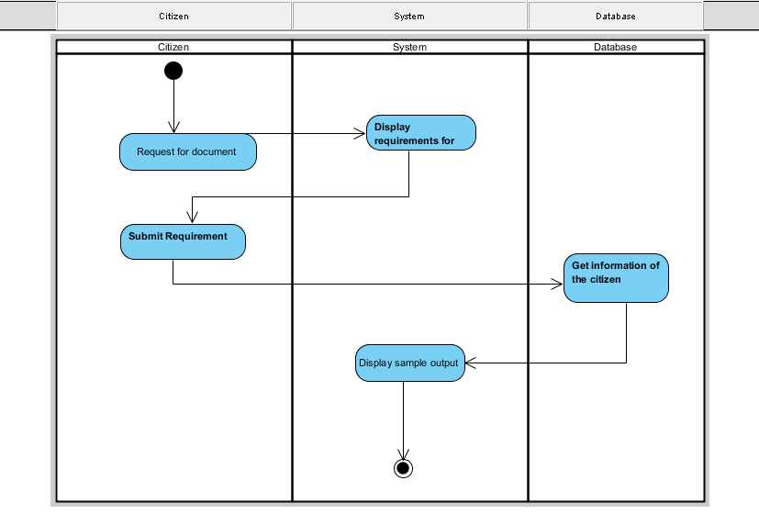

(Citizen Register)

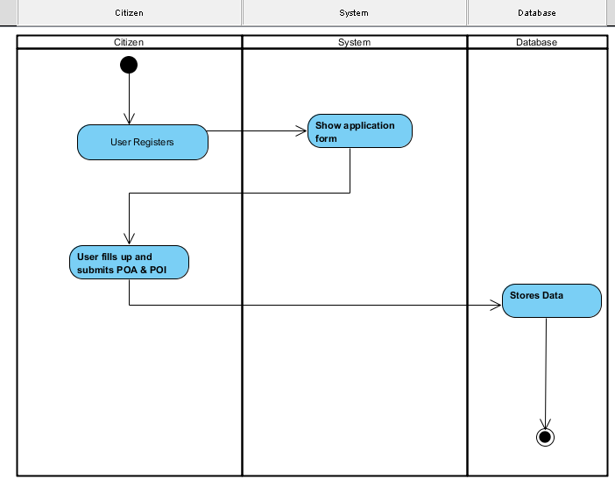

(Check File Service Request) 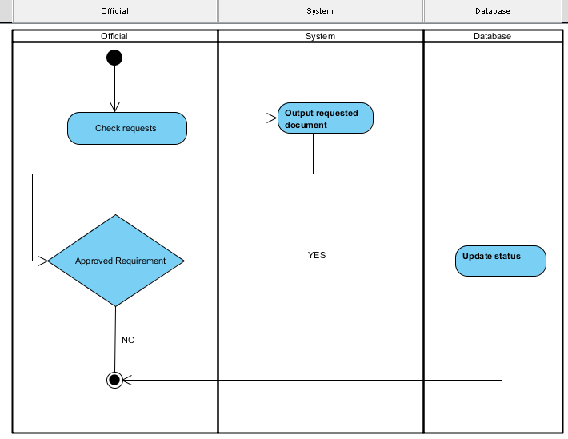

(Verify Proof of Identity / Address (POI / POA))

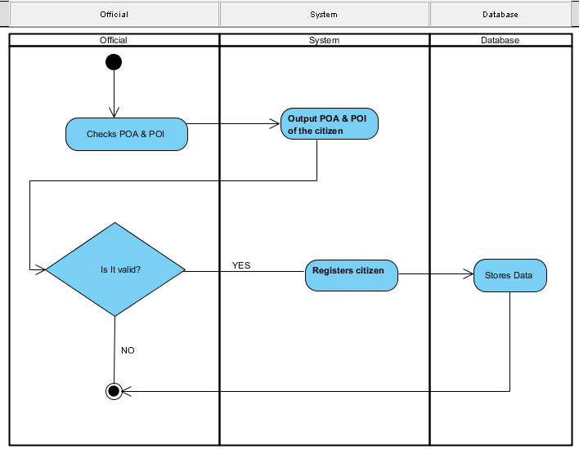

(Update Bulletin)

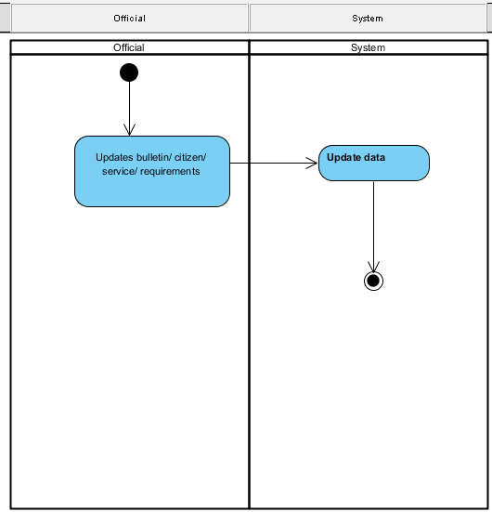

## Sequence Diagram

(Check File Service Request)

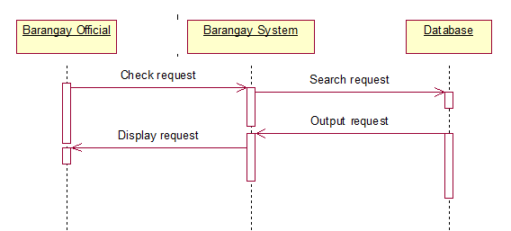

(Citizen Register)

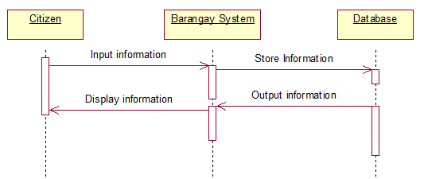

(File Service Request)

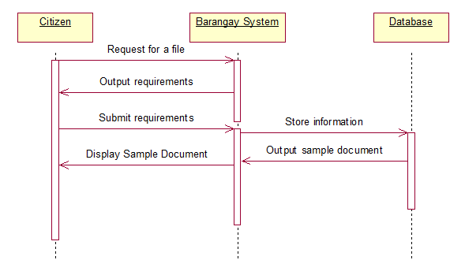

(Select Service)

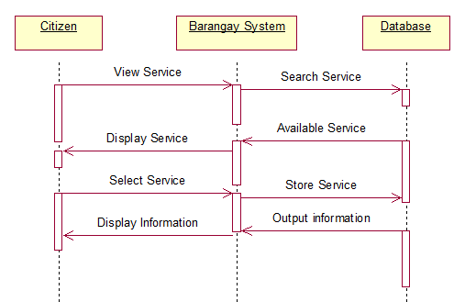

(Update Bulletin)

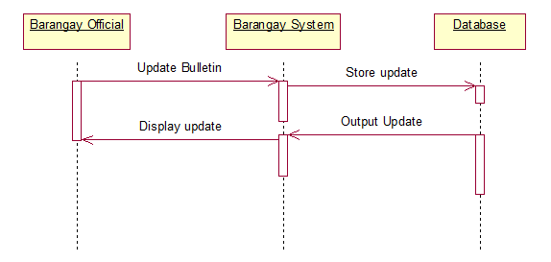  
(Verify Proof of Identity / Address (POI / POA))

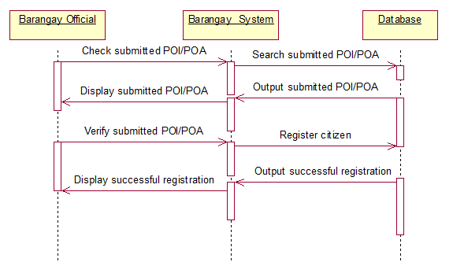

## Collaboration Diagram

(Check File Service Request)

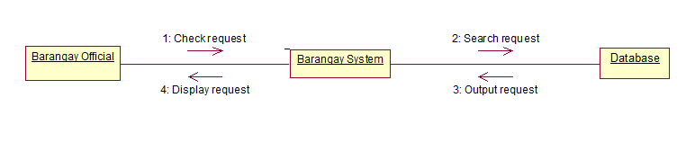

(Citizen Register)

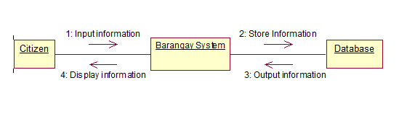

(File Service Request)

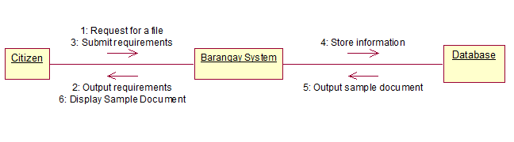

(Select Service) 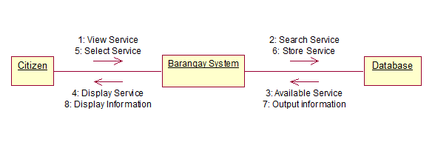

(Update Bulletin)

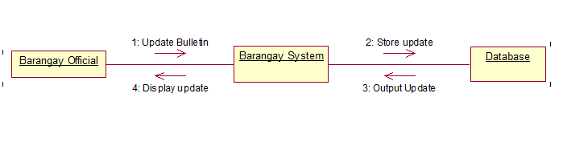

(Verify Proof of Identity / Address (POI / POA))

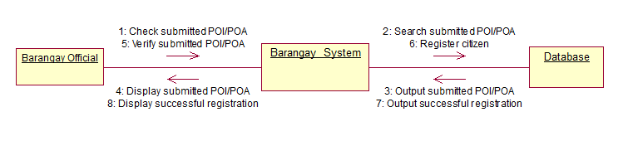

## Component Diagram

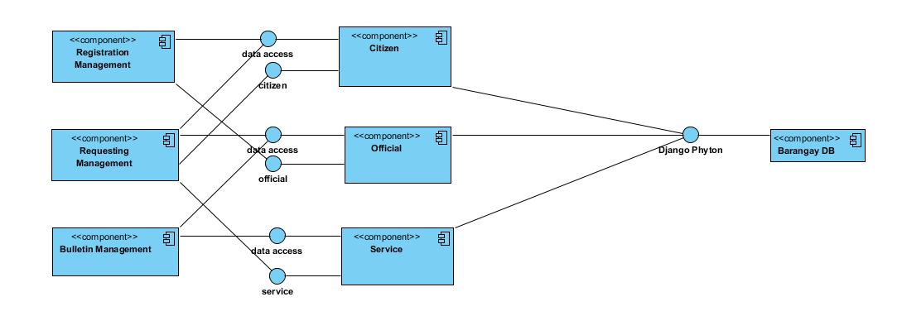

## Composite Diagram

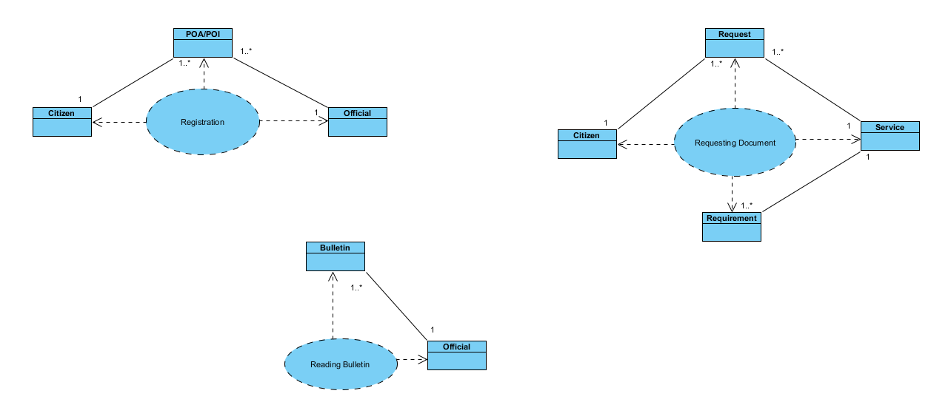

## Deployment Diagram

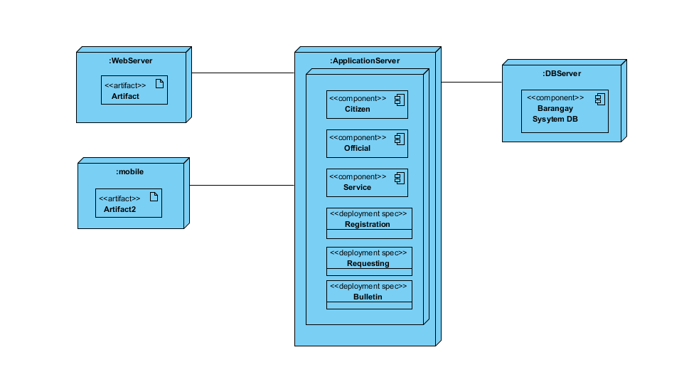

## Interaction Diagram

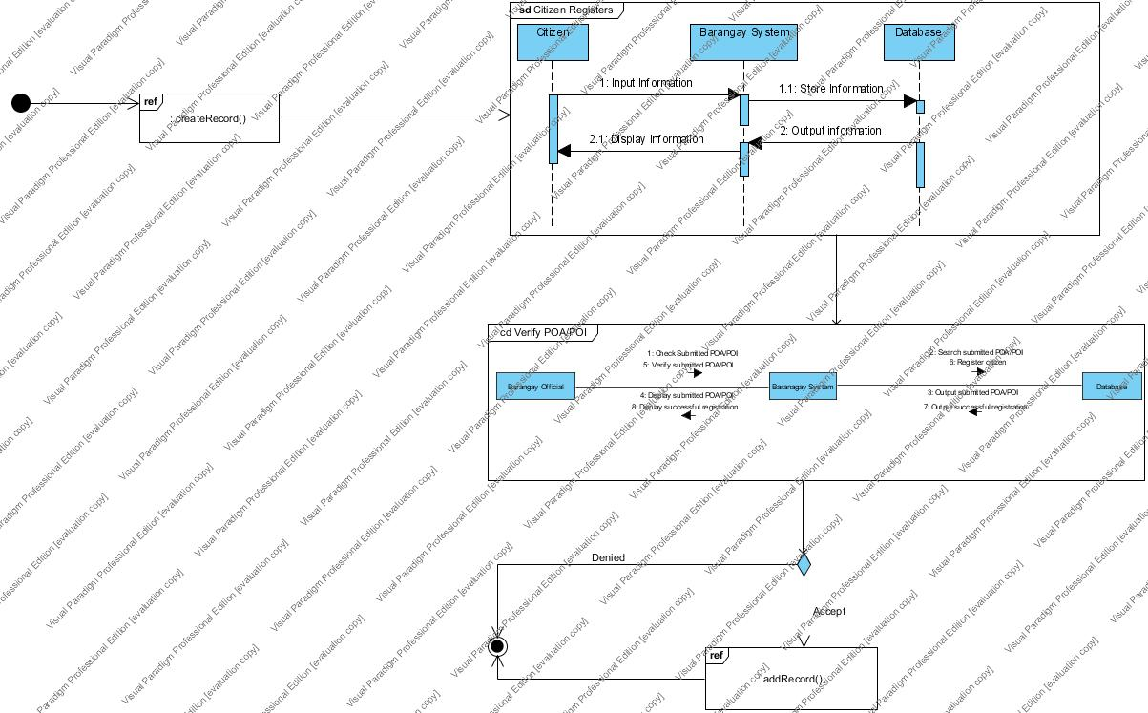

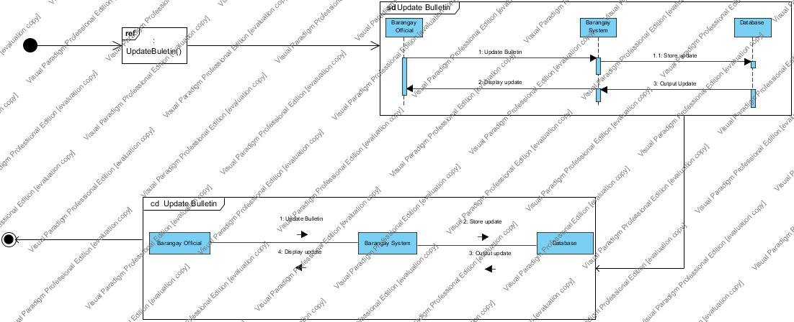

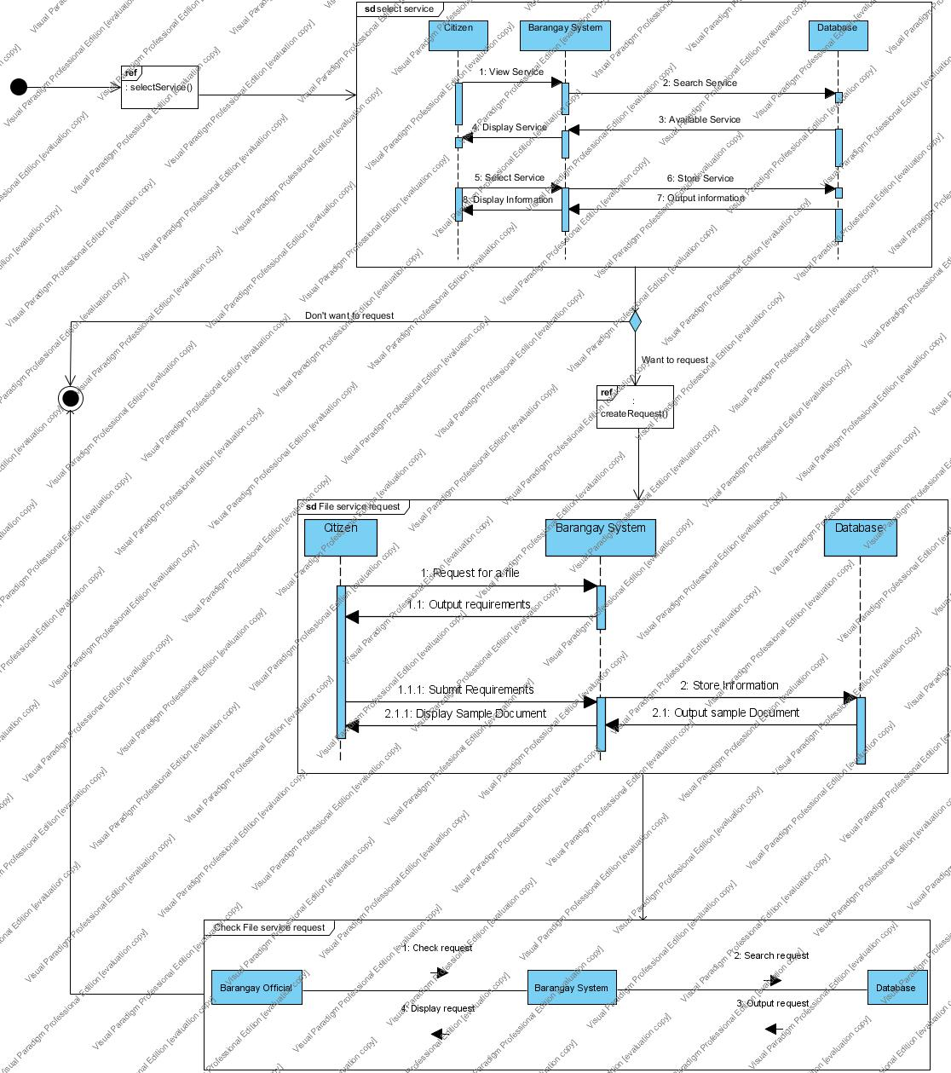

## Package Diagram

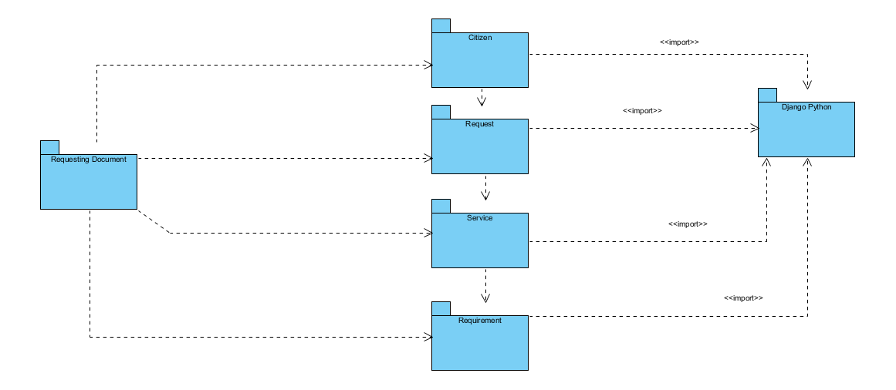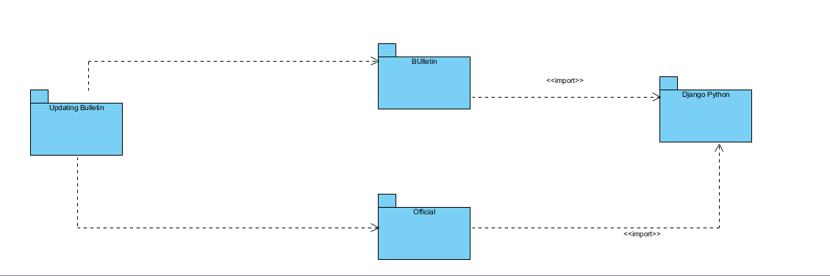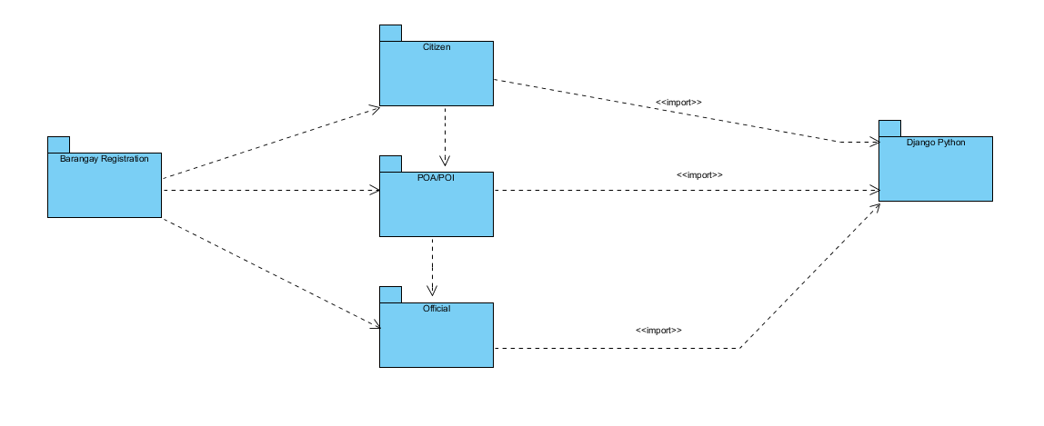

## Object Diagram

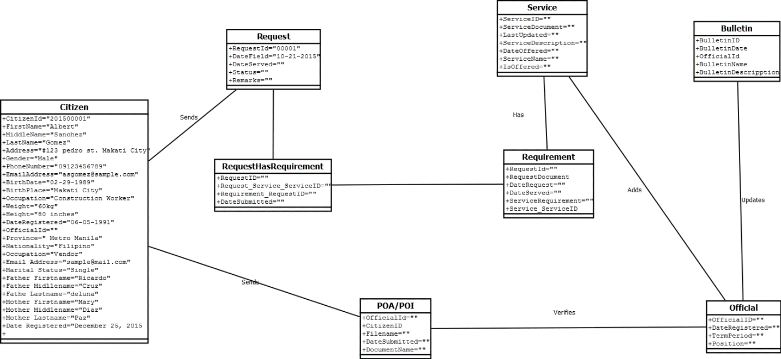

## State-Machine Diagram

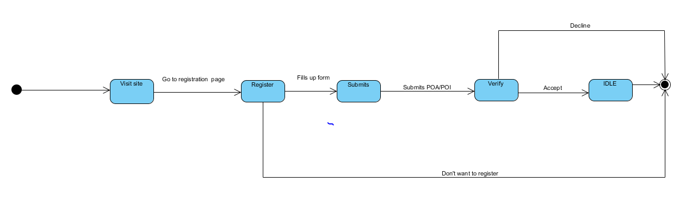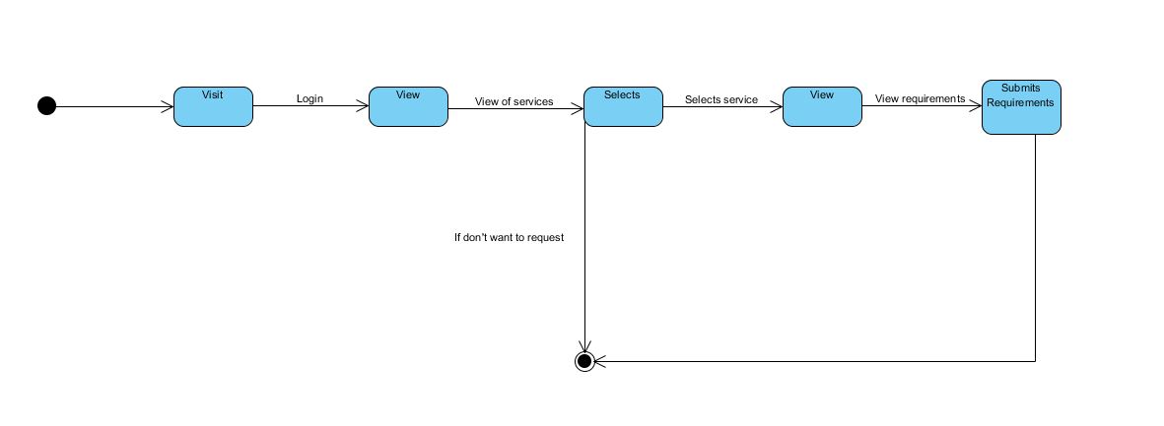

## Timing Diagram

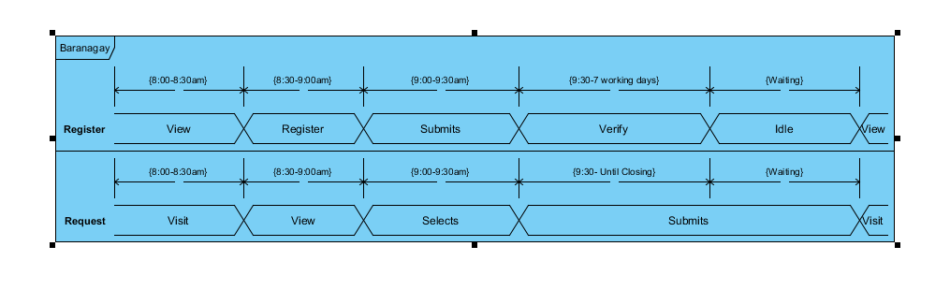

# **X. SCREENSHOTS**

# **XI. SOURCE CODE LISTING OF EACH MODULE**

# **XII. BIBLIOGRAPHY**